Supplementary Material

Supplementary Table S1. SHAP Feature Importance by Category
Feature | Rural (Class 0) | Transitional (Class 1) | Urban (Class 2) | Mean |SHAP|
Fat energy ratio | — | — | — | 0.512
Carbohydrate energy ratio | — | — | — | 0.166
Protein energy ratio | — | — | — | 0.140
Fat-to-carbohydrate ratio | — | — | — | 0.094
Survey year | — | — | — | 0.088
Province | — | — | — | 0.133
Values represent mean absolute SHAP value for each feature-category combination. Higher values indicate greater influence on model predictions for that category. Class 0 = Rural, Class 1 = Transitional, Class 2 = Urban. Mean |SHAP| is averaged across the three categories.

Supplementary Table S2. SHAP Feature Interaction Strengths (Top 15 Pairs)
Rank | Feature 1 | Feature 2 | Interaction Strength
1 | Fat energy ratio | Carbohydrate energy ratio | 0.0506
2 | Fat energy ratio | Survey year | 0.0267
3 | Protein energy ratio | Survey year | 0.0208
4 | Fat energy ratio | Protein energy ratio | 0.0205
5 | Protein energy ratio | Province | 0.0200
6 | Carbohydrate energy ratio | Survey year | 0.0194
7 | Carbohydrate energy ratio | Province | 0.0192
8 | Fat energy ratio | Province | 0.0182
9 | Fat energy ratio | Fat-to-carbohydrate ratio | 0.0152
10 | Carbohydrate energy ratio | Protein energy ratio | 0.0135
11 | Fat-to-carbohydrate ratio | Survey year | 0.0128
12 | Protein energy ratio | Fat-to-carbohydrate ratio | 0.0114
13 | Carbohydrate energy ratio | Fat-to-carbohydrate ratio | 0.0109
14 | Fat-to-carbohydrate ratio | Province | 0.0098
15 | Survey year | Province | 0.0086
Interaction strength represents the mean absolute SHAP interaction value for the Urban category (Class 2). Interaction effects accounted for 19.8% of total model importance.

Supplementary Table S3. Leave-one-province-out spatial validation. Mean accuracy 0.737 (SD 0.052). Lower performance in Beijing, Shanghai, and Chongqing reflects smaller test samples and distinct urban dietary profiles.
Province | N (Test) | Accuracy | Macro-F1 | Cohen's κ
Guangxi | 13,384 | 0.780 | 0.739 | 0.635
Guizhou | 12,257 | 0.752 | 0.696 | 0.631
Henan | 11,983 | 0.770 | 0.661 | 0.628
Hubei | 11,202 | 0.782 | 0.781 | 0.607
Hunan | 11,113 | 0.750 | 0.766 | 0.618
Jiangsu | 11,059 | 0.748 | 0.775 | 0.584
Shandong | 10,610 | 0.782 | 0.743 | 0.577
Liaoning | 8,853 | 0.765 | 0.778 | 0.592
Heilongjiang | 7,435 | 0.756 | 0.710 | 0.595
Shanghai | 1,468 | 0.670 | 0.680 | 0.474
Beijing | 1,289 | 0.649 | 0.700 | 0.456
Chongqing | 1,273 | 0.641 | 0.706 | 0.441
Mean ± SD | — | 0.737 ± 0.052 | 0.728 ± 0.041 | 0.570 ± 0.072
Each row represents a model trained on all provinces except the test province. Lower performance in Beijing, Shanghai, and Chongqing reflects the more extreme urban dietary patterns and steeper urban–rural gradients in these provincial-level municipalities.

Supplementary Table S4. Feature-set ablation under Plan B (T2 administrative labels with transitional FatER overlay). Macronutrients and spatiotemporal covariates contributed jointly; year and province alone performed near chance for three-class inference.
Feature Set | Accuracy | Macro-F1 | Cohen's κ | JS Divergence
Full (6 features) | 0.7824 | 0.7698 | 0.6355 | —
Macronutrients only (4 features) | 0.7687 | 0.7507 | 0.6102 | —
Year + Province only (2 features) | 0.5179 | 0.2576 | 0.0244 | —
KNN Baseline (6 features) | 0.7077 | 0.6905 | — | —
Feature-set ablation showed that inference relied on combined macronutrient and spatiotemporal information rather than any single predictor. Because Transitional labels incorporate FatER 23–30%, high Transitional accuracy is expected and should be interpreted alongside Urban accuracy.

Supplementary Table S5. Missing rate sensitivity: category-specific accuracy. Transitional accuracy remained high across missing rates because this stratum is partially defined by FatER thresholds; Urban accuracy remained near 0.42–0.43, reflecting difficult administrative-urban inference.
Missing Rate | Rural | Transitional | Urban
10% | 0.888 | 0.991 | 0.430
20% | 0.887 | 0.991 | 0.413
30% | 0.879 | 0.993 | 0.421
40% | 0.878 | 0.992 | 0.429
50% | 0.874 | 0.992 | 0.422
60% | 0.872 | 0.992 | 0.426
70% | 0.873 | 0.992 | 0.434
Transitional category accuracy exceeded 0.99 at all missing rates, consistent with partial definitional overlap between the Transitional stratum and macronutrient predictors.

Supplementary Table S6. Hyperparameter Configuration for Balanced XGBoost
Parameter | Value | Purpose
Boosting rounds | 600 | Extended for finer-grained learning
Maximum tree depth | 4 | Control model complexity
Learning rate | 0.05 | Reduced to prevent overfitting
Subsample ratio | 0.9 | Fraction of samples per tree
Column sampling ratio | 0.9 | Fraction of features per split
Minimum child weight | 5 | Conservative split threshold
Gamma | 0.2 | Minimum loss reduction for partition
L1 regularisation (α) | 0.5 | Additional overfitting protection
L2 regularisation (λ) | 1.2 | Additional overfitting protection
Hyperparameters were selected via grid search with five-fold cross-validation on the training set.

Supplementary Methods: SHAP Analysis Details
SHAP (SHapley Additive exPlanations) values were computed using TreeExplainer for XGBoost models. For multi-class classification, SHAP values were calculated separately for each category, with analysis focused on the Urban category. Temporal and spatial stratification were performed by grouping observations by survey year and province, respectively, and computing mean absolute SHAP values within each group. Feature interaction strengths were derived from SHAP interaction values. All analyses were conducted on the held-out test set (n = 20,386).

Supplementary Figure S1. SHAP Summary Plot (Global Feature Importance)
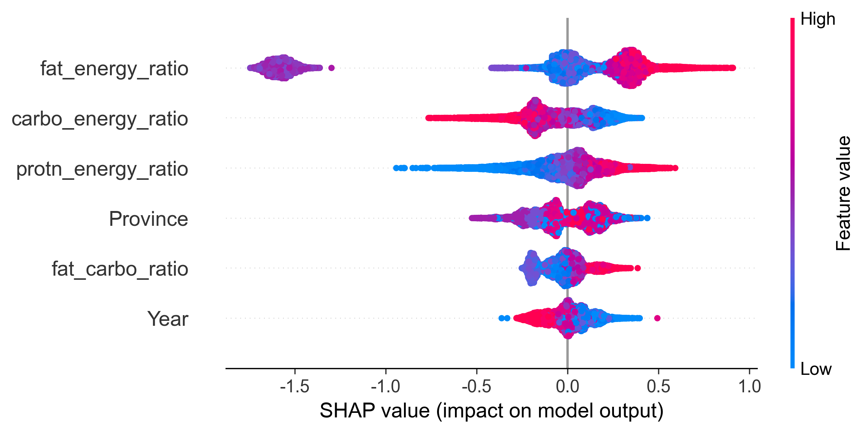
Figure S1. SHAP summary plot showing global feature importance and directional effects for Urban category classification. Each point represents a SHAP value for an individual observation. Features are ordered by mean absolute SHAP value (descending). Positive SHAP values (right of zero) push predictions toward Urban classification; negative values push toward Rural. Fat energy ratio was the most influential feature (mean |SHAP| = 0.554), with higher values generally contributing to Urban classification. Survey year showed consistent positive contributions, reflecting secular trends toward urbanised dietary patterns.

